8.2.7 Lab–Use a Calculator for Binary Conversions

(Instructor Version)

Instructor Note: Red font color or gray highlights indicate text that appears in the instructor copy only.

# Objectives

■ Switch among Windows Calculator modes.

■ Use Windows Calculator to convert between decimal and binary.

■ Use Windows Calculator to determine the number of hosts in a network with powers of 2.

# Background / Scenario

When working with networking devices, a network technician should understand binary and decimal numbers. In this lab, you will use the Windows Calculator application to convert between these numbering systems. You will also use the “powers” function to determine the number of hosts that can be addressed based on the number of bits available.

# Required Resources

■ PC (Windows 10)

# Instructions Part 1: Using Windows Calculator

Step 1: Access Windows Calculator and determine mode of operation.

1. Open the Windows Calculator application. Click Start, type Calculator. Select Calculator in the results.

Question:

What mode is the Calculator in?

**Scientific**

Answers can vary. It can be in the Standard, Scientific, Programmer, Date calculator, or Converter.

1. Click the Open Navigation icon (≡) located in the upper left-hand corner. The Windows calculator supports different mode of calculations.

Question:

List the five modes for the calculator.

**Standard, scientific, graphing, programmer, and date calculation.**

The five calculator modes are Basic, Scientific, Programmer, Date calculation, and Converter.

Step 2: Switch between modes.

1. To switch between calculator modes, click the Open Navigation icon (≡) and select desired mode.
2. Practice switching between calculator modes to see which options they provide.

Question:

Briefly explain the function of each mode.

* Basic mode is used to perform basic math calculations.
* Scientific mode is used to perform more advanced math calculations such as logarithm etc..
* Graphing mode is used to trace the graph
* Date calculation mode is used for working with dates.
* Converter mode is used to convert between different units.

The standard mode is for basic math. The Scientific mode is for more advanced calculations. The Programmer mode supports different number systems, such as binary, hexadecimal, octal, and decimal. The Date calculation mode is for working with dates. The Converter is for converting between different units of measurement.

# Part 2: Binary System

Step 1: Convert between number systems.

1. Select the Programmer mode calculator.
2. The Programmer calculator supports four numbering systems — HEX (Hexadecimal), DEC (Decimal), OCT (Octal), and BIN (Binary).

Questions:

Which number system is currently active?

Decimal (DEC)

DEC

Which numbers on the number pad are active in Decimal mode?

0 to 9

* 1. thru 9

1. Click BIN.

Questions:

Which numbers on the number pad are now active?

0 and 1

* 1. and 1

Why do you think the other numbers are grayed out?

Because binary only has 2 distinct digits which are 0 and 1.

Because the only digits used in binary (Base 2) are 0 and 1

1. Click DEC. Using your mouse, click on the number 1 followed by the number 5 on the number pad. The decimal number 15 has now been entered.
2. Now click BIN.

Question:

What happened to the number 15 listed in the textbox at the top of the window?

Number switches to 1111.

It converted the decimal number 15 to four binary 1 digits (1111)

1. Enter the number 220 and select BIN. Question:

What is the binary equivalent of 220?

11011100

11011100

1. Clear the binary value representing 220 in the window. From Binary mode, type in the following binary number: 11001100. Select the DEC.

Question:

What is the decimal equivalent to the binary number of 11001100?

204

204

Step 2: Practice the conversion between binary and decimal numbering system.

Questions:

Convert the following decimal numbers to binary.

|  |  |
| --- | --- |
| Decimal | Binary |
| 86 | 01010110 |
| 175 | 10101111 |
| 204 | 11001100 |
| 19 | 00010011 |

Convert the following binary numbers to decimal.

|  |  |
| --- | --- |
| Binary | Decimal |
| 1100 0011 | 195 |
| 0010 1010 | 42 |
| 0011 1000 | 56 |
| 1001 0011 | 147 |

# Part 3: Network Addresses

Step 1: Convert host IP addresses.

1. Computer hosts usually have two addresses, an Internet Protocol (IP) address and an Ethernet Media Access Control (MAC) address. For the benefit of humans, the IP address is normally represented in dotted decimal notation, such as 192.168.10.2. Each of the decimal octets in the address or a mask can be converted to 8 binary bits. Remember that the computer only understands binary bits.

Question:

If all 4 octets were converted to binary, how many bits would there be?

32 bits

IP address is 32 bits, 4x8

1. IP addresses are normally shown with four decimal numbers ranging from 0 to 255 and separated by a period.

Question:

Convert the 4 parts of the IP address 192.168.10.2 to binary.

|  |  |
| --- | --- |
| Decimal | Binary |
| 192 | 11000000 |
| 168 | 10101000 |
| 10 | 1010 |
| 2 | 10 |

Step 2: Convert host IP subnet masks.

Subnet masks, such as 255.255.255.0, are also represented as dotted decimal. A subnet mask will always consist of four 8-bit octets, each one represented as a decimal number. With the exception of decimal 0 (all 8 binary zeros) and decimal 255 (all 8 binary ones), each octet will have some number of ones on the left and some number of zeros on the right.

Questions:

Convert the 8 possible decimal subnet octet values to binary.

|  |  |
| --- | --- |
| Decimal | Binary |
| 0 | 00000000 |
| 128 | 10000000 |
| 192 | 11000000 |
| 224 | 11100000 |
| 240 | 11110000 |
| 248 | 11111000 |
| 252 | 11111100 |
| 254 | 11111110 |
| 255 | 11111111 |

Convert the four parts of the subnet mask 255.255.255.0 to binary.

|  |  |
| --- | --- |
| Decimal | Binary |
| 255 | 11111111 |
| 255 | 11111111 |
| 255 | 11111111 |
| 0 | 00000000 |

Step 3: Manipulate powers of 2 to determine the number of hosts on a network.

1. Binary numbers use two digits, 0 and 1. When you calculate how many hosts can be on a subnetwork, you use powers of two because binary is being used. As an example, we have a subnet mask that leaves six bits in the host portion of the IP address. In this case, the number of hosts on that network is 2 to the 6th power minus 2 (because you need a number to represent the network and a number that can be used to reach all the hosts—the broadcast address). The number 2 is always used because we are working in binary. The number 6 is the number of bits that are used for the host bits.
2. Change the calculator view to Scientific mode. Input the number 2. Select the xy key on the calculator, the key which raises a number to a power. Input the number 6. To complete the operation, click on the = key, press Enter on the keyboard, or press the = key on the keyboard. The number 64 appears in the output. To subtract two, click on the minus (-) key and then the 2 key followed by the = key. The number 62 appears in the output. This means 62 hosts could be utilized.

Questions:

Using the previously described process, determine the number of hosts if the following number of bits are used for host bits.

|  |  |
| --- | --- |
| No. of Bits Used for Hosts | No. of Hosts |
| 5 | 30 |
| 14 | 16382 |
| 24 | 16777214 |
| 10 | 1022 |

Using a similar technique as learned previously, determine what 10 to the 4th power equals.

10000

10000

1. Close the Windows Calculator application.

# Reflection

List one other thing for which you might use the Windows Calculator scientific mode. It does not have to be related to networking.

|  |  |
| --- | --- |
| Answers will vary. As an example, the scientific mode can be used for calculating the angles | |
| and length of a triangle for engineering problems. |  |

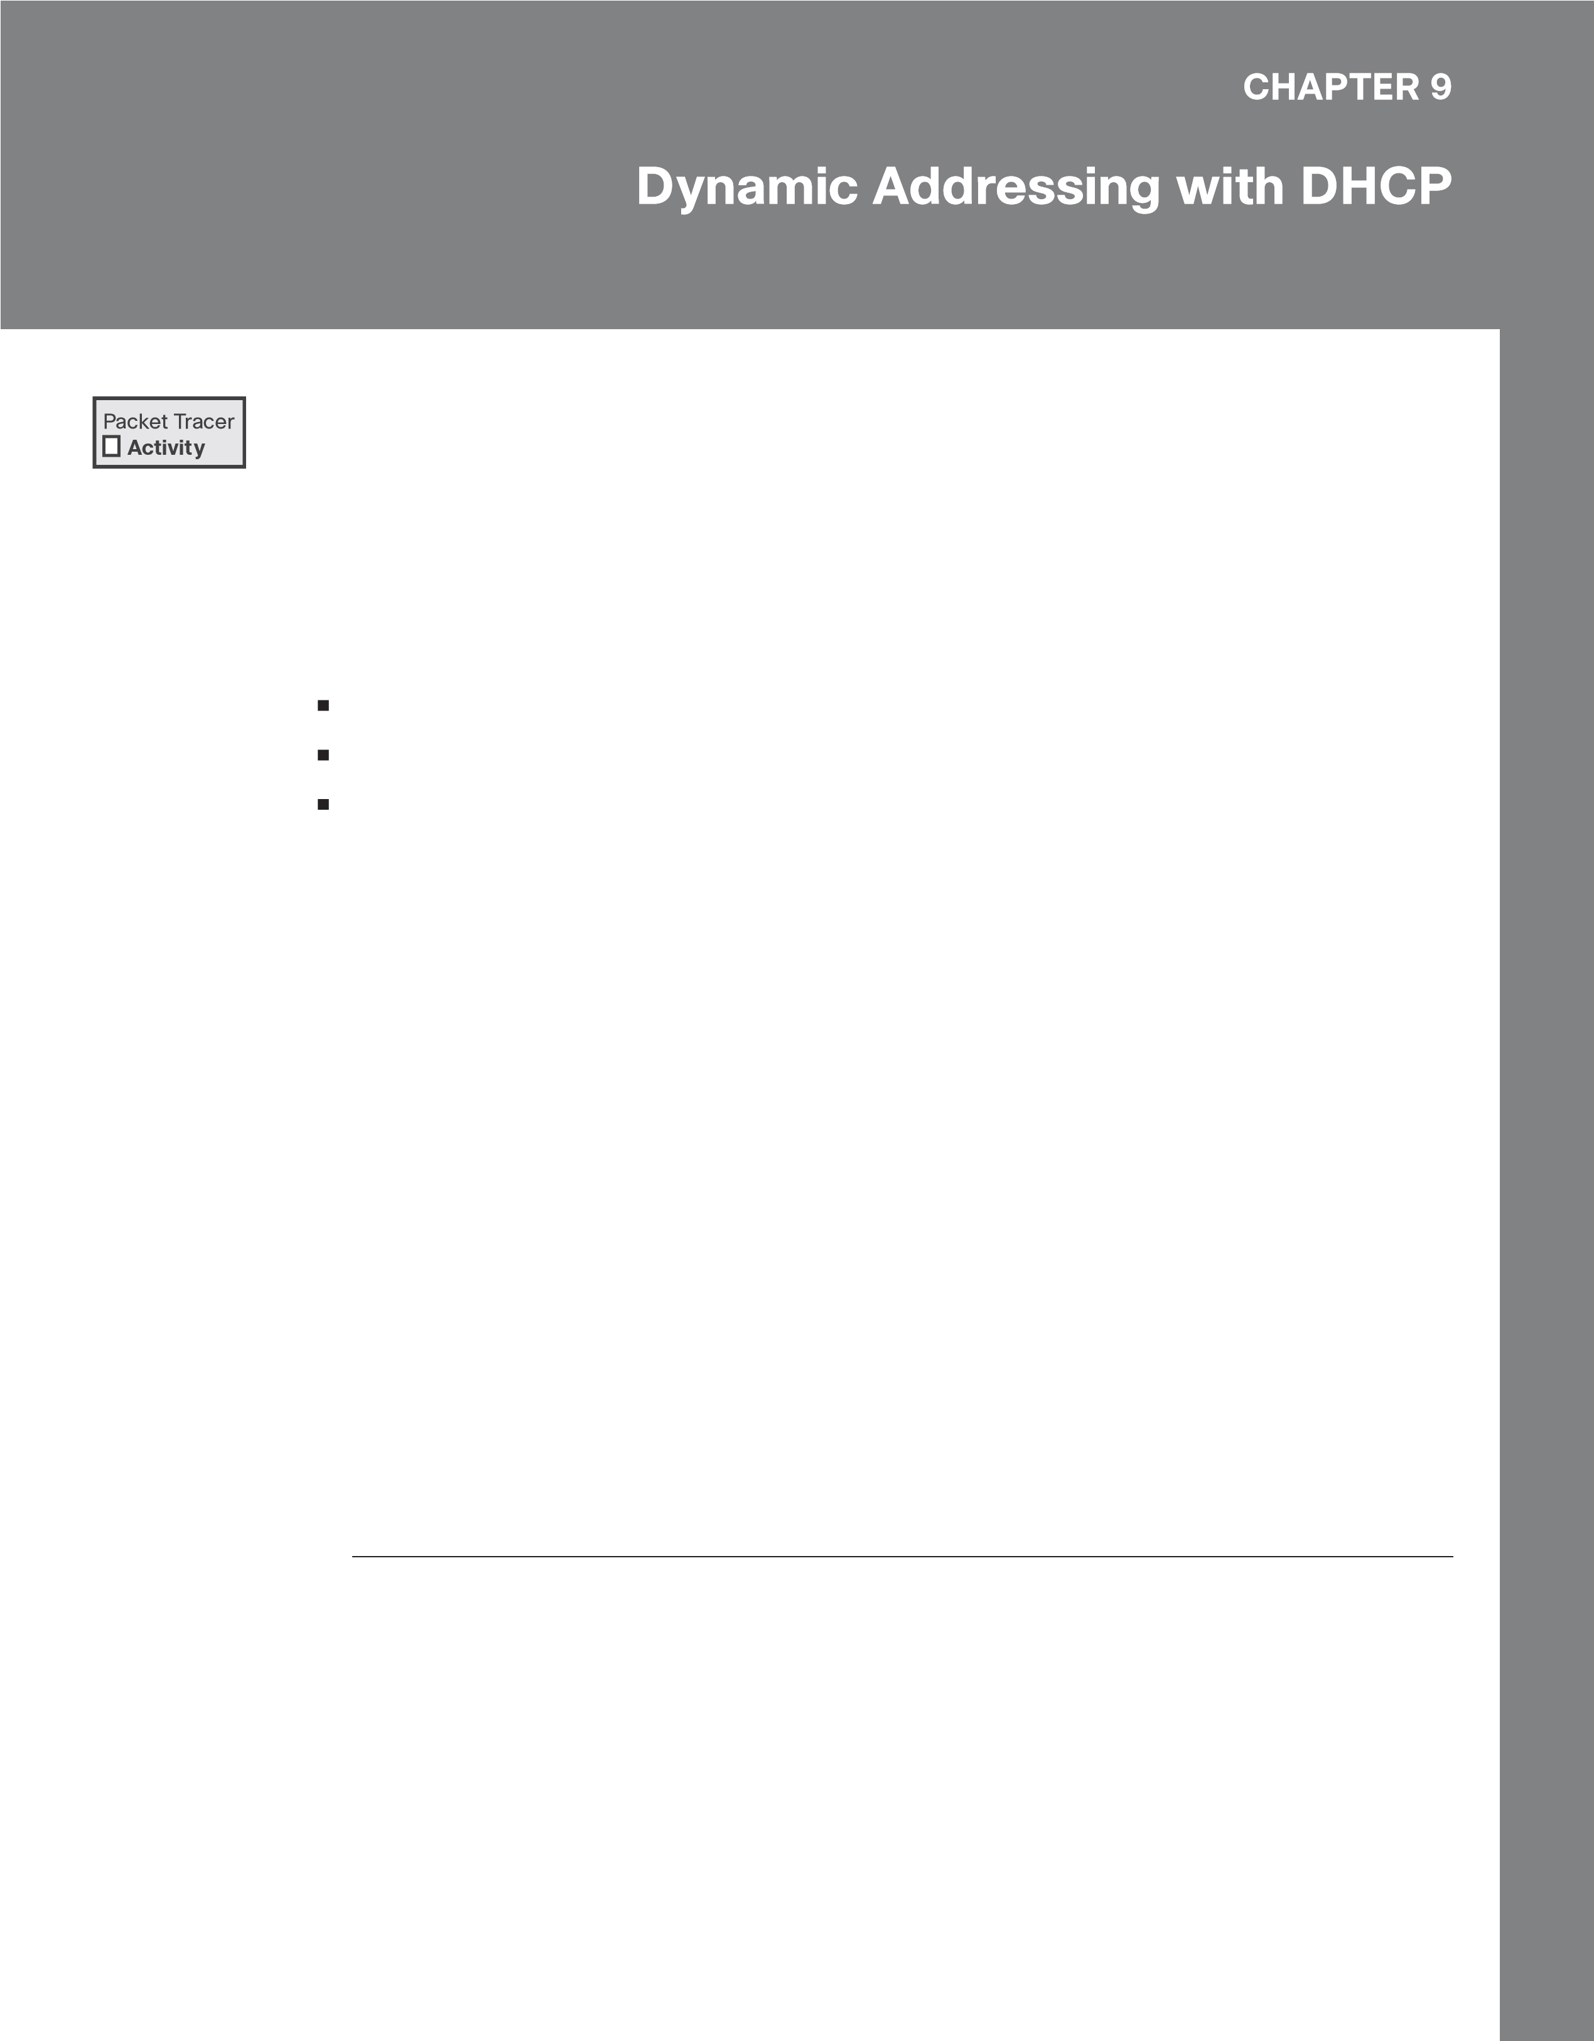9.2.5 Packet Tracer–Configure DHCP on a Wireless Router (Instructor Version)

Instructor Note: Red font color or gray highlights indicate text that appears in the instructor copy only.

# Objectives

■ Connect 3 PCs to a wireless router.

■ Change the DHCP setting to a specific network range.

■ Configure clients to obtain their address via DHCP.

# Background / Scenario

A home user wants to use a wireless router to connect 3 PCs. All 3 PCs should obtain their address automatically from the wireless router.

# Instructions Part 1: Set Up the Network Topology

1. Add three generic PCs.
2. Connect each PC to an Ethernet port on the wireless router using straight-through cables.

# Part 2: Observe the Default DHCP Settings

1. After the amber lights have turned green, click PC0. Click the Desktop tab. Select IP Configuration. Select DHCP to receive an IP address from the DHCP Enabled Router.

Question:

Record the IP address of the default gateway:

192.168.0.1

1. Close the IP Configuration window.
2. Open a web browser.
3. Enter the IP address of the default gateway recorded earlier into the URL field. When prompted, enter the username admin and password admin.
4. Scroll through the Basic Setup page to view default settings, including the default IP address of the wireless router.
5. Notice that DHCP is enabled, and note the starting address of the DHCP range and the range of addresses available to clients.

Part 3: Change the Default IP Address of the Wireless

# Router

1. Within the Router IP Settings section, change the IP address to: 192.168.5.1.
2. Scroll to the bottom of the page and click Save Settings.
3. If it is done correctly, the web page will display an error message. Close the web browser.
4. Click IP Configuration to renew the assigned IP address. Click Static. Click DHCP to receive new IP address information from the wireless router.
5. Open the web browser and enter the IP address 192.168.5.1 in the URL field. When prompted, enter the username admin and password admin.

# Part 4: Change the Default DHCP Range of Addresses

1. Notice the DHCP Server Start IP Address is updated to the same network as the Router IP.
2. Change the Starting IP Address from 192.168.5.100 to 192.168.5.126.
3. Change the Maximum Number of Users to 75.
4. Scroll to the bottom of the page and click Save Settings. Close the web browser.
5. Click IP Configuration to renew the assigned IP address. Click Static. Click DHCP to receive new IP address information from the wireless router.
6. Select Command Prompt. Enter ipconfig. Question:

Record the IP address for PC0:

192.168.5.126

# Part 5: Enable DHCP on the Other PCs

1. Click PC1.
2. Select the Desktop tab.
3. Select IP Configuration.
4. Click DHCP. Question:

Record the IP address for PC1:

192.168.5.127

Chapter 9: Dynamic Addressing with DHCP 67

1. Close the configuration window.
2. Enable DHCP on PC2 following the steps for PC1.

# Part 6: Verify Connectivity

1. Click PC2 and select the Desktop tab.
2. Select Command Prompt.
3. Enter ipconfig at the prompt to view the IP configuration.
4. At the prompt, enter ping 192.168.5.1 to ping the wireless router.
5. Enter ping 192.168.5.126 to ping PC0 at the prompt.
6. At the prompt, enter ping 192.168.5.127 to ping PC1.
7. The pings to all devices should be successful.

Instructor Note: Red font color or gray highlights indicate text that appears in the instructor copy only.

# Objectives

■ Examine NAT configuration on a wireless router.

■ Set up 4 PCs to connect to a wireless router using DHCP.

■ Examine traffic that crosses the network using NAT.

# Instructions Part 1: Examine the Configuration for Accessing External Network

1. Add 1 PC and connect it to the wireless router with a straight-through cable. Wait for all link lights to turn green before moving onto the next step or click Fast Forward.
2. On the PC, click Desktop. Select IP Configuration. Click DHCP to enable each device to receive an IP address via the DHCP on the wireless router.
3. Note the IP address of the default gateway. Close the IP Configuration window when done.
4. Navigate to the web browser and enter the IP address of the default gateway in the URL field. Enter the username admin and password admin when prompted.
5. Click the Status menu option in the upper right-hand corner. When selected, it displays the Router sub-menu page.
6. 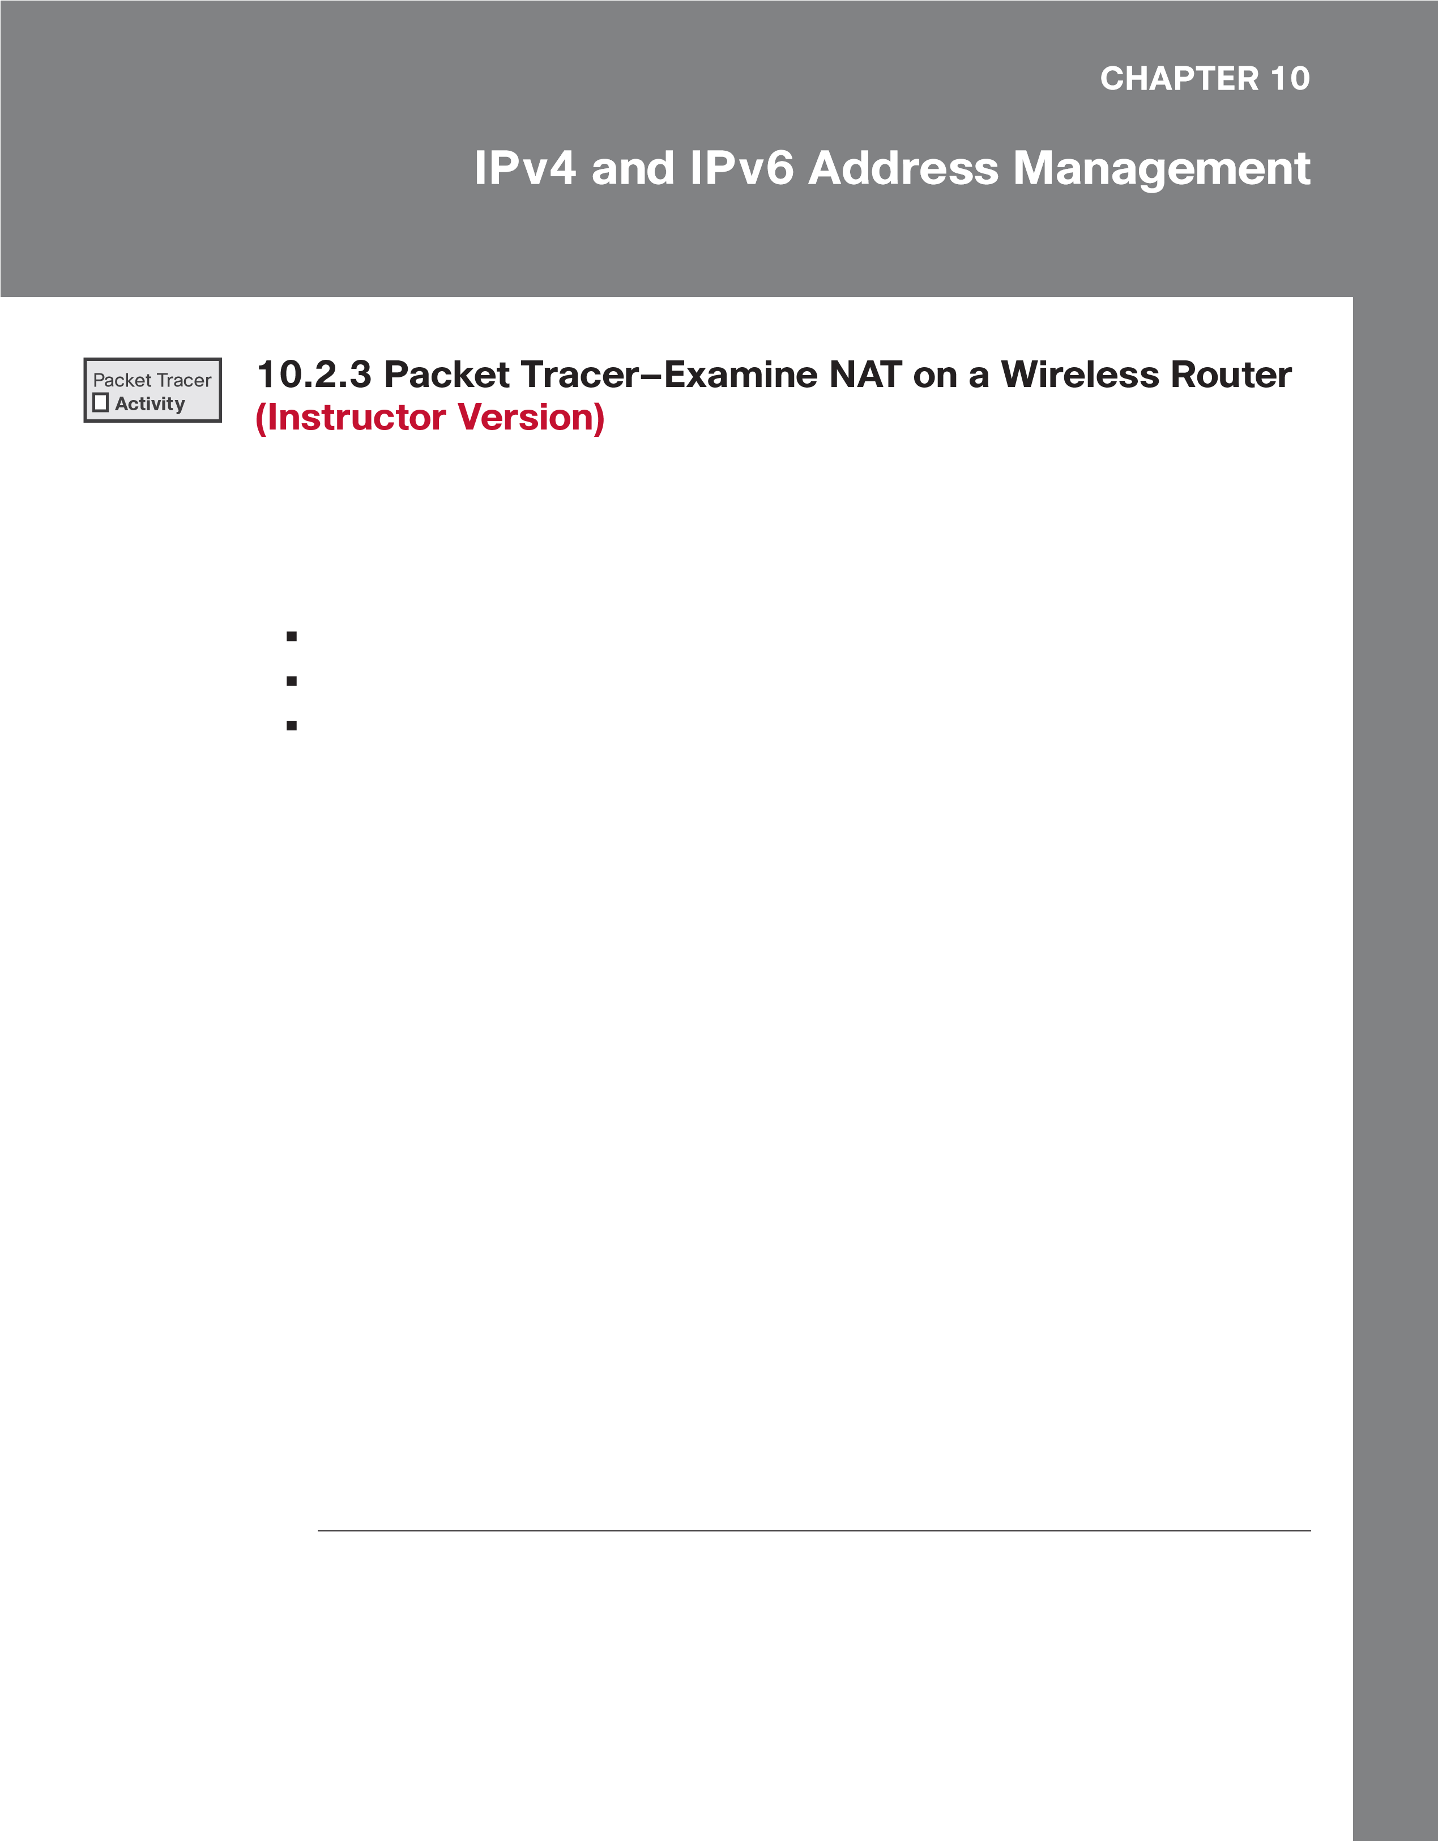Scroll down the router page to the Internet connection option. The IP address assigned here is the address assigned by the ISP. If no IP address is present (0.0.0.0 appears), close the window, wait for a few seconds and try again. The wireless router is in the process of obtaining an IP address from the ISP DHCP server.

The address seen here is the address assigned to the Internet port on the wireless router.

Question:

Is this a private or public address?

Public IP address

70 Networking Essentials Lab Manual

Part 2: Examine the Configurations for Accessing the

# Internal Network

1. Click Local Network within the Status sub-menu bar.
2. Scroll down to examine the Local Network information. This is the address assigned to the internal network.
3. Scroll down further to examine the DHCP server information, and range of IP addresses that can be assigned to connected hosts.

Question:

Are these private or public addresses?

Private IP address

1. Close the wireless router configuration window.

# Part 3: Connect 3 PCs to the Wireless Router

1. Add 3 more PCs and connect them to the wireless router with straight-through cables. Wait for all link lights to turn green before moving on to the next step or click Fast Forward.
2. On each PC, click Desktop. Select IP Configuration. Click DHCP to enable each device to receive an IP address via the DHCP on the wireless router. Close the IP Configuration window when done.
3. Click Command Prompt to verify each device IP configuration using the ipconfig /all command.

Note: These devices will receive a private address. Private addresses are not able to cross the Internet; therefore, NAT translation must occur.

# Part 4: View NAT Translation Across the Wireless Router

1. Enter Simulation Mode by clicking the Simulation tab in the lower right-hand corner. The Simulation tab is located next to the Realtime tab and has a stopwatch symbol.
2. View traffic by creating a Complex PDU in Simulation Mode:
   * 1. From the Simulation Panel, click Show All/None to change visible events to none. Now click Edit Filters and under the Misc tab, checkmark the boxes for TCP and HTTP. Close the window when done.
     2. Add a Complex PDU by clicking on the opened envelope located in upper menu.
     3. Click one of the PCs to specify it as the source.
3. Specify the Complex PDU settings by changing the following within the complex PDU window:
   1. Under PDU Settings > Select Application should be set to: HTTP.
   2. Click ciscolearn.nat.com server to specify it as the destination device.

Chapter 10: IPv4 and IPv6 Address Management 71

* 1. For the Source Port, enter 1000.
  2. Under Simulation Settings, select Periodic. Enter 120 seconds for the Interval. 5) Click Create PDU in the Create Complex PDU window.

1. Double-click the simulation panel to unlock it from the PT window. This enables you to move the simulation panel to view the entire network topology.
2. Observe the traffic flow by clicking Play in the simulation panel. Speed up the animation by sliding the play control slider to the right.

Note: Click View Previous Events when the Buffer Full message is displayed.

Part 5: View the Header Information of the Packets that

# Traveled Across the Network

1. Examine the headers of the packets sent between a PC and the web server.
   1. In the Simulation Panel, double click the 3rd line down in the event list. This displays an envelope in the work area that represents that line.
   2. Click the envelope in the work area window to view the packet and header information.
2. Click the Inbound PDU details tab. Examine the packet information for the source (SRC) IP address and destination IP address.
3. Click the Outbound PDU details tab. Examine the packet information for the source (SRC) IP address and destination IP address. Notice the change in SRC IP address.
4. Click through other event lines to view those headers throughout the process.
5. When finished, click Check Results to check your work.